WALEMERA CLUSTER MOCK EXAMINATIONS
2022 MALAWI SCHOOL CERTIFICATE OF EDUCATION EXAMINATIONS

CHEMISTRY
Subject Number: M036/I
Time Allowed: 2 hours
08:00 – 10:00 am
Paper I
(100 marks)

Question  Number | Tick if  answered | Do not write in  these columns
1
2
3
4
5
6
7
8
9
10
11
12
13
Instructions:
- This paper contains 12 printed pages. Please check.
- Write your name at the top of each page.
- This paper contains two sections, A and B. In section A there are ten short answer questions while in Section B there are three restricted essay questions.
- Answer all the thirteen questions in the spaces provided.
- Use of a calculator is allowed.
- The maximum number of marks for each answer is indicated against each question.
- In the table provided on this page, tick against the number of the question you have answered.

SECTION A (70 marks)
1 a. Explain the following observation.
(i) Solid sodium chloride (NaCl) does not conduct electricity but molten sodium chloride conducts electricity.
_________________________________________________________________________________________________ _____________________________________________________________________________________ 2 marks
(ii) Metals are good conductors of electricity and heat.
_________________________________________________________________________________________________ _____________________________________________________________________________________ 2 marks
(iii) Ionic compounds generally have higher melting and boiling points than covalent compounds.
________________________________________________________________________________________________________________________________________________________________________________________________ 2 marks

b. Define the term ‘electron configuration’
______________________________________________________________________________ ______________________________________________________________________________ _______________________________________________________________________ 1 marks
c. Element X has a mass number of 27 and atomic number 13.
i. To which group and period does element X belong
a. group___________________________________________________________________________ 1 mark
b. period __________________________________________________________________________1 mark
ii. Give a reason for your answer to 1(ci) above
_______________________________________________________________________________________________________ _______________________________________________________________________________________________________ _____________________________________________________________________________________________ 3 marks

iii Derive a chemical formula of compound that would be formed when element X reacts with oxygen atom.

- marks
d. Figure 1 is a graph of atomic radius across the periods against atomic number for the first 20 element in the periodic table
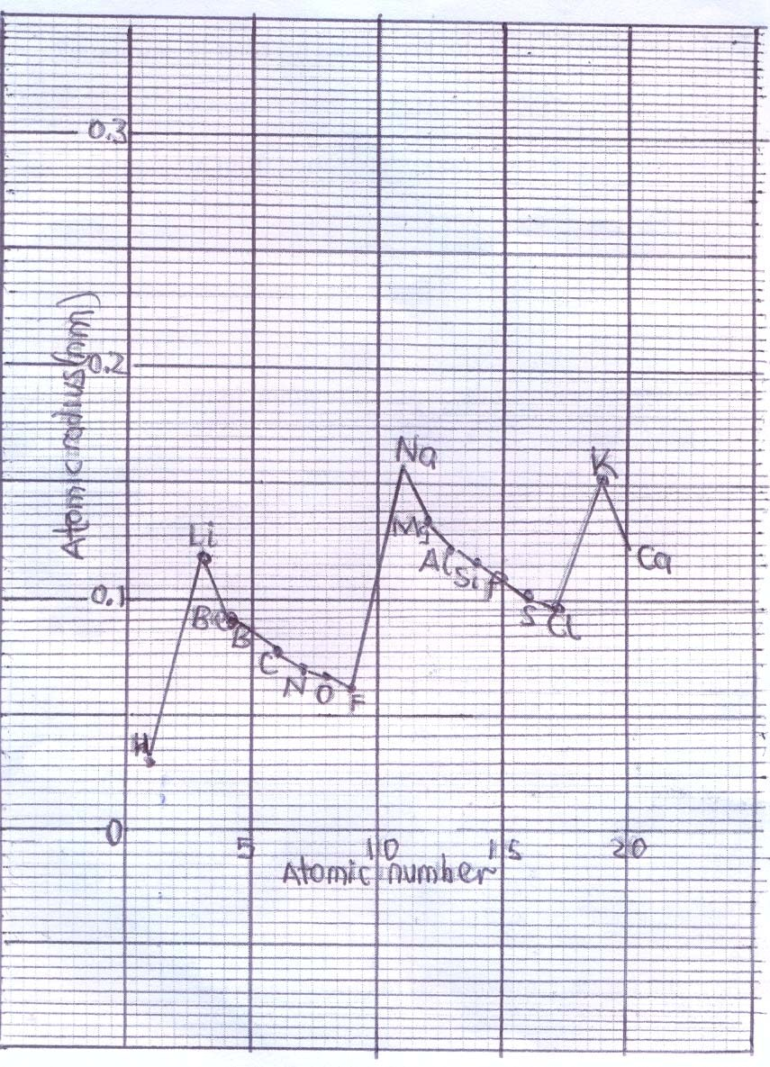
Figure 1
    - Identify the atomic radius of N
_______________________________________________________________________________________1 mark
    - Why is there a sudden increase in atomic radius from F to Na?
_________________________________________________________________________________________________
_____________________________________________________________________________________ 1 mark
    - In terms of the periodic table explain why an atomic radius is different from an ionic size of the same element
________________________________________________________________________________________________
______________________________________________________________________________2 marks

- a. Define the following terms:
(i). Rate of reaction
_________________________________________________________________________________________________________
______________________________________________________________________________________________ 1 mark
(ii). Chemical equilibrium
_________________________________________________________________________________________________________
______________________________________________________________________________________________1mark
b. Outline three points under collision theory.
_________________________________________________________________________________________________________ _________________________________________________________________________________________________________ ________________________________________________________________________________________________ 3 marks
c. A chemical reaction causes the concentration of a reactant to change from 1.8 mol/dm³ to 0.6 mol /dm³ after 4 minutes. Calculate the rate of reaction.

3 marks

    - Hydrogen peroxide decomposes according to the equation below:
MnO₂
H₂O₂ (l) 2H₂O (l) + O₂ (g)
      - What is the use of manganese oxide and how does it perform its function in the reaction?
_________________________________________________________________________________________________
_____________________________________________________________________________________ 2 marks

      - Sketch on the same axes, two graphs one labelled A (use of catalyst) and the other
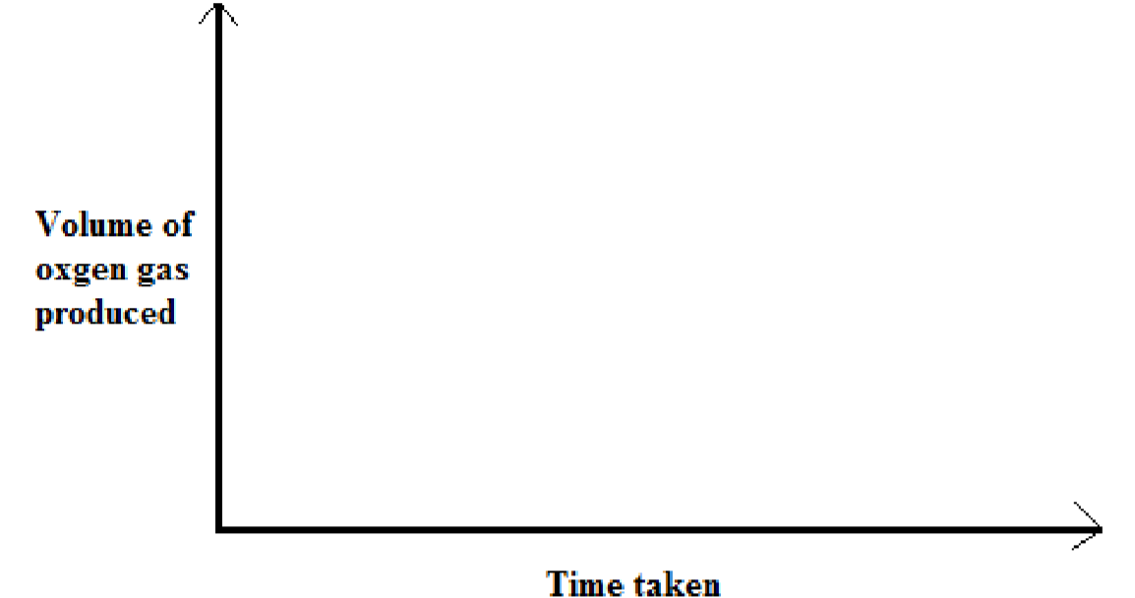
labelled
B

(
non
-
use of catalyst).

2 marks
- a. Define a base according to Bronsted-Lowry theory of acids and bases.
______________________________________________________________________________________________ 1 mark
  - What is the difference between an acid and a conjugate acid?
_________________________________________________________________________________________________________
_____________________________________________________________________________________________ 2 marks
  - Identify conjugate acid-base pairs in the following equations
(i). HCl + NH₃ NH₄⁺ + Cl–
_____________________________________________________________________________________________ 2 marks
(ii). H₂SO₄ + NH₃ HSO₄⁻ + NH₄⁺
_____________________________________________________________________________________________ 2 marks
  - Explain any two applications of precipitation reactions in our everyday life.
_________________________________________________________________________________________________________ _________________________________________________________________________________________________________ _________________________________________________________________________________________________________ _____________________________________________________________________________________________ 2 marks
- a. State the difference between oxidation and reduction in terms of electrons.
_________________________________________________________________________________________________________ _________________________________________________________________________________________________________
_____________________________________________________________________________________________ 2 marks

    - Below is an ionic equation between silver and copper ions.
Ag⁺(aq) + Cu⁺(aq) Ag(s) + Cu²⁺(aq)
i. Write the oxidation and reduction half equations from the equation
Oxidation half equation: _________________________________________ 1 mark
Reduction half equation: ________________________________________ 1 mark
ii. Write the overall balanced equation
________________________________________________________________________
________________________________________________________________________ ________________________________________________________________________
_______________________________________________________________ 2 marks

b.
Calculate oxidation number of P in PO
4
3
-
.

2
marks

- . a.Figure 2 below is a diagram showing the manufacturing of ammonium nitrate.
Figure 2

Reactant A Reactant B

Reaction

Ammonia (NH
3

)
Reaction

Chamber 1Chamber 2

Nitrogen

Ammonium nitrate

(
NH
4
NO
3
)

i. Name reactants A and B.
Reactant A: _______________________________________________ 1 mark
Reactant B:_______________________________________________ 1 mark
ii. What is the source of nitrogen used in reaction chamber 1?
__________________________________________________________ 1 mark
b. (i) Define a “hydrate”.
________________________________________________________________________
________________________________________________________________ 1 mark

(ii) Calculate the percentage of water of crystallization in hydrated sodium sulphate

(
Na2
₂
SO
4
.10
H
2
O ) (Mr: Na = 23
, S = 32, O = 16, H = 1)

3

marks

f. Figure 3 below shows the standard hydrogen electrode used to measure the electrode potential zinc half-cell. Use it to answer the questions that follow.

Connecting wire

V

hydrogen gas in

at 25
0
C and 1 atm salt bridge

part B

Platinised electrode

1
M H
+

ions

Zinc ions

Container X Container Y
Figure 3
i. Why should the platinum electrode be platinized?
___________________________________________________________________ 1 mark
ii. Describe the two roles of the salt bridge
___________________________________________________________________________ ___________________________________________________________________________
__________________________________________________________________ 2 marks
iii. Name the electrode labelled part B.
___________________________________________________________________ 1 mark
iv. Write the oxidation half equation for the electrochemical cell above.
___________________________________________________________________ 1 mark

- a. Define the term “isomers”.
______________________________________________________________________________
______________________________________________________________________ 1 mark

  - Below are the general formulae for some organic compounds:
      - CnH2_{n+1}OH
      - CnH2_{n}O
      - CnH2n+2
      - CnH2_{n+1} COOH
i. Identify a compound which is insoluble in water.
________________________________________________________________ 1 mark
ii. Write the condensed formula for a compound with 5 carbon atoms from compound R.
______________________________________________________________ 1mark
iii.

Draw structures of

two

isomers of compound P with 4 carbon atoms

.

(
2

marks)

7. a. Table 1 the structural formulae of some monomers and polymers that can be made from them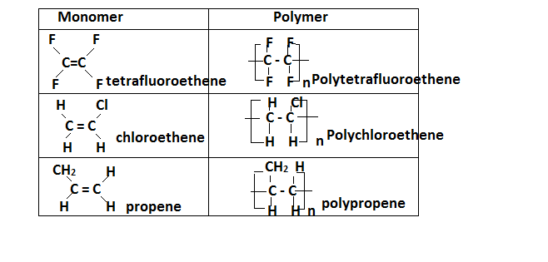
- What type of polymerization will the monomers undergo to form the polymers?
________________________________________________________________________1 mark
- What feature present in the monomers shows that they can undergo the type of polymerization mentioned in 7a(i) above?
______________________________________________________________________________1mark
- Figure below shows structures of plastics of A and B.
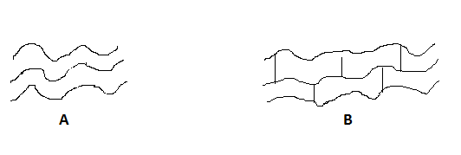
- Which structure represents thermosetting plastics
__________________________________________________________________________1 mark
- Give reason for your answer above
_____________________________________________________________________________1 mark

- a. Define the term “bond energy”.
______________________________________________________________________________
______________________________________________________________________ 1 mark

  - Differentiate exothermic reaction from endothermic reaction.
______________________________________________________________________________ ______________________________________________________________________________ _____________________________________________________________________________ 2 marks
  - Hydrogen reacts with bromine to form hydrogen bromide according to the equation:
H2 (g) + Br2 (g) 2HBr (g). Using the bond energies in the table below, calculate the heat of the reaction.
Bond | Bond Energies(kJ/mol)
H – H | 436
Br – Br | 193
H – Br | 365

3
marks

- a. (i) Define a mole.
_________________________________________________________________________________________________________ ______________________________________________________________________________________________ 1 mark
(ii) Balance the equation below: CuO + NH₃ Cu + H₂O + N₂

_____________________________________________________________________________________2 marks
b. A compound has the following percentage composition by mass of elements:
(
i
)

Find the empirical formula of the compound C = 26.087%, H = 4.348% and O = 69.565%

3
marks

(
ii
)

Determine the
molecular formula of the compound if its relative formula mass is 92.

c. (i) Discuss the difference between theoretical yield and actual yield of a chemical reaction.
_________________________________________________________________________________________________________
_________________________________________________________________________________________________________
_________________________________________________________________________________________________________
_____________________________________________________________________________________________ 2 marks
      - After doing her calculations based on a chemical equation of a reaction, a form 4 student found that 16g of the product will be produced but after the chemical reaction it was 12.5 g of the product by weighing it on a balance. Calculate the percentage yield.

2 marks
9. a. When 160 g of solid anhydrous copper sulphate (CuSO₄) dissolves in 1000 cm³ of water, an energy change of -57 kJ/mole is observed. When 250 g of solid hydrated copper sulphate (CuSO₄.5H₂O) dissolves in 1000 cm³ of water, energy of +10 kJ/mole is observed.
i Which reaction is exothermic? __________________________________________________________ 1mark

- Which reaction results in fall (decrease) in temperature?
______________________________________________________________________________________ 1 mark
- Draw an energy level diagram which shows the dissolving of anhydrous copper
sulphate
(
Cu
SO
4
)
in water.

3
marks

b. (i) What is an end point?
_________________________________________________________________________________________________________
_________________________________________________________________________________________________________
______________________________________________________________________________________________ 1 mark
(ii) The following are results a form three girl found after doing titration of HCl solution against 20 cm³ of Na₂CO₃solution in order to find the concentration of HCl.

BURETTE READINGS | VOLUME (cm³)
Final burette reading | 22.5
Initial burette reading | 0.00
Volume of HCl used

- Find the volume of HCl used and record it in the table. 1 mark
- Balance the equation for the reaction.
HCl + Na₂CO₃ NaCl + H₂O + CO₂ 2 marks

3.

Calculate the concentration of HCl if the molarity of Na
2
CO
3

is 0.2 M.

3
marks

- a. In an investigation a student wanted to find out the effect of adding impurities to pure water on its boiling point.
  - Define a scientific investigation.
_________________________________________________________________________________________________ ______________________________________________________________________________________ 1 mark
  - Identify the dependent and independent variables.
- Dependent variable: _______________________________________________________________________
- Independent variable: ___________________________________________________________ 2 marks
  - Suggest one hypothesis for the investigation.
_________________________________________________________________________________________________ ______________________________________________________________________________________ 1 mark

Section B (30 marks)

- a. By providing examples, describe two types of oxides.
_________________________________________________________________________________________________________ _________________________________________________________________________________________________________ _________________________________________________________________________________________________________
_____________________________________________________________________________________________ 4 marks

b. Discuss three methods of preparing salts. Include relevant chemical equation for each method you mention.
_________________________________________________________________________________________________________
_________________________________________________________________________________________________________ _________________________________________________________________________________________________________ _________________________________________________________________________________________________________
_________________________________________________________________________________________________________
_________________________________________________________________________________________________________
_________________________________________________________________________________________________________
________________________________________________________________________________________________ 6 marks
12.a . Discuss any two environmentally friendly ways of treating and disposing wastes.
_________________________________________________________________________________________________________ _________________________________________________________________________________________________________ _________________________________________________________________________________________________________
________________________________________________________________________________________________ 4 marks
b. Describe the ‘greenhouse effect’?
_________________________________________________________________________________________________________
_________________________________________________________________________________________________________ _________________________________________________________________________________________________________
____________________________________________________________________________________________________3 marks

  - Explain how you can test the presence of hydrogen gas.
_________________________________________________________________________________________________________ _________________________________________________________________________________________________________
_________________________________________________________________________________________________________ _________________________________________________________________________________________________________
_____________________________________________________________________________________________ (3 marks)
13. a. Using a well-labelled diagram, describe how an spoon can be electroplated using silver nitrate (AgNO₃). Your description should include all necessary equations.

_________________________________________________________________________________________________________
_________________________________________________________________________________________________________
_________________________________________________________________________________________________________
_________________________________________________________________________________________________________
_________________________________________________________________________________________________________ _________________________________________________________________________________________________________ _________________________________________________________________________________________________________
_____________________________________________________________________________________________ 10 marks

